Carbon Reduction Plan

Supplier name: Cpl Resources Ltd.
Publication date: 10/10/2025

Commitment to achieving Net Zero
The Cpl Group, including all entities, is committed to achieving Net Zero emissions by 2045.

Baseline Emissions Footprint
Baseline emissions are a record of the greenhouse gases that have been produced in the past and were produced prior to the introduction of any strategies to reduce emissions. Baseline emissions are the reference point against which emissions reduction can be measured.

Baseline Year: January - December 2024
Additional Details relating to the Baseline Emissions calculations.
We have recently updated our Baseline year to 2024 due to a number of acquisitions in the business.
Baseline year emissions:
Scope 1 | 122.75 tCO2e  Scope 1: (0.7% of total emissions) come from stationary combustion (natural gas) and mobile combustion (diesel, petrol).
Scope 2 | Location Rate - 146.68 tCO2e  Market Rate – 124.66 tCO2e  Scope 2 emissions (0.8%) are measured using two approaches:  - Location-based, which reflects the carbon intensity of the national grid. The location-based approach is used in the chart.  - Market-based, which considers the carbon intensity of your electricity providers.
Scope 3  (Included Sources) | 18,159.97 tCO2e  Scope 3 emissions account for ~98.5% of the company’s total emissions, with the largest contributor being Category 1 Purchased Goods & Services, representing 63.2% of Scope 3 emissions in 2024.
  1. Purchased Goods & Services | 11,482.80
  2. Capital Goods | 4,168.36
  3. Other Fuel & Energy Related Activities | 77.41
  4. Upstream Transportation & Distribution | 13.26
  5. Waste | 2.86
  6. Cpl Business Travel | 413.12
  6. Client Business Travel | 1,350.96
  7. Employee Commuting | 651.19
Total Emissions | 18,429.4 tCO2e

Current Emissions Reporting

Reporting Year: January - December 2024
Scope 1 | 122.75 tCO2e  Scope 1: (0.7% of total emissions) come from stationary combustion (natural gas) and mobile combustion (diesel, petrol).Increase is due to change in boundary.
Scope 2 | Location Rate - 146.68 tCO2e  Market Rate – 124.66 tCO2e  Scope 2 emissions (0.8%) are measured using two approaches:  - Location-based, which reflects the carbon intensity of the national grid. The location-based approach is used in the chart.  - Market-based, which considers the carbon intensity of your electricity providers.
Scope 3  (Included Sources) | 18,159.97 tCO2e  Scope 3 emissions account for ~98.5% of the company’s total emissions, with the largest contributor being Category 1 Purchased Goods & Services, representing 63.2% of Scope 3 emissions in 2024.
  1. Purchased Goods & Services | 11,482.80
  2. Capital Goods | 4,168.36
  3. Other Fuel & Energy Related Activities | 77.41
  4. Upstream Transportation & Distribution | 13.26
  5. Waste | 2.86
  6. Cpl Business Travel | 413.12
  6. Client Business Travel | 1,350.96
  7. Employee Commuting | 651.19
Total Emissions | 18,429.4 tCO2e

Emissions reduction targets
Our 2024 Emissions have not been published as of yet, however you can see previous emissions information in our Sustainability Strategy and Report.

We have committed to achieving total Net Zero emissions (including scope 3) by 2045, 5 years ahead of the 2050 deadline called for in the Paris Agreement (Paris Agreement to the United Nations Framework Convention on Climate Change). As of May 2025 Cpl is committed to setting both Near Term and Net Zero Targets through SBTi.
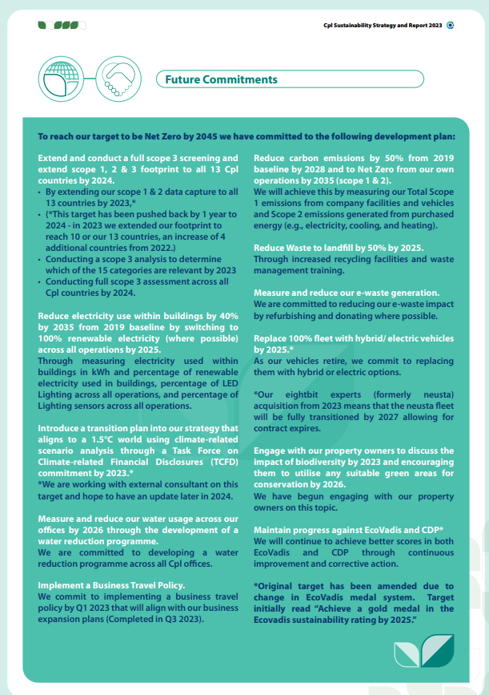

Carbon Reduction Projects
Please see our Sustainability Strategy and Report to further details on our Carbon Reduction Projects.

Declaration and Sign Off
This Carbon Reduction Plan has been completed in accordance with PPN 06/21 and associated guidance and reporting standard for Carbon Reduction Plans.
Emissions have been reported and recorded in accordance with the published reporting standard for Carbon Reduction Plans and the GHG Reporting Protocol corporate standard and uses the appropriate Government emission conversion factors for greenhouse gas company reporting.
Scope 1 and Scope 2 emissions have been reported in accordance with SECR requirements, and the required subset of Scope 3 emissions have been reported in accordance with the published reporting standard for Carbon Reduction Plans and the Corporate Value Chain (Scope 3) Standard.
This Carbon Reduction Plan has been reviewed and signed off by the board of directors (or equivalent management body).

Signed on behalf of the Supplier:

Sharon Vize
Chief People Officer and Executive Sustainability Sponsor
………………………………………………………………….
Date: 10/10/2025

https://ghgprotocol.org/corporate-standard
https://www.gov.uk/government/collections/government-conversion-factors-for-company-reporting
https://ghgprotocol.org/standards/scope-3-standard

